**this document contains the commands executed and the corresponding outputs for Git Hands-**On Lab 3 (HOL 3).  
The outputs are based on the provided screenshots.

**Branch Creation, Commit, Merge, and Push**

**Commands Executed**

* git branch Gitbranch
* git checkout Gitbranch
* echo "This is new branchfile" > branchfile.txt
* 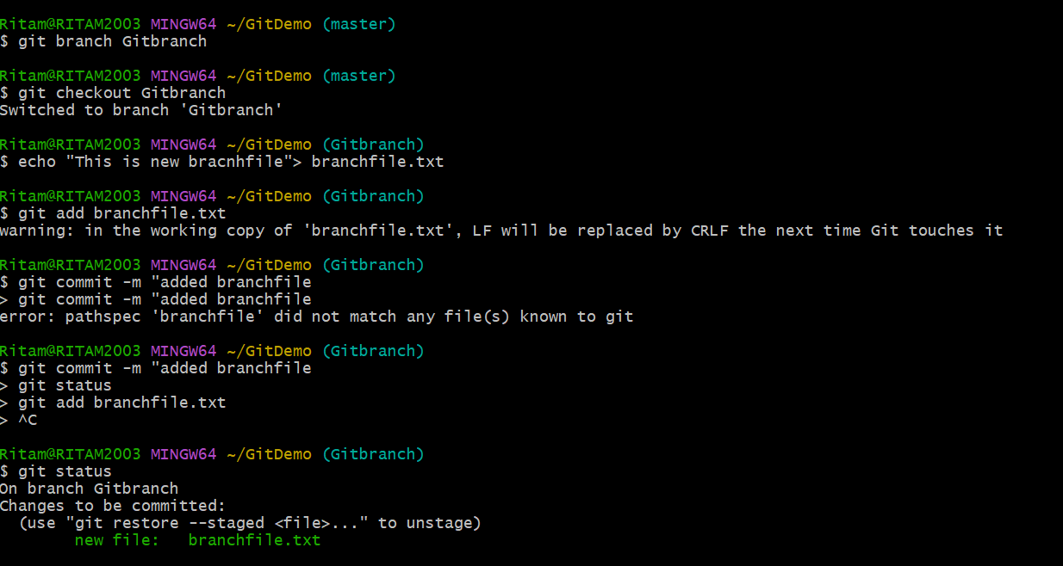git add branchfile.txt
* git commit -m "added branchfile"
* git status
* git checkout master
* git diff Gitbranch
* git merge Gitbranch
* git log --oneline --graph --decorate
* git branch -d Gitbranch
* git status
* git push origin master

